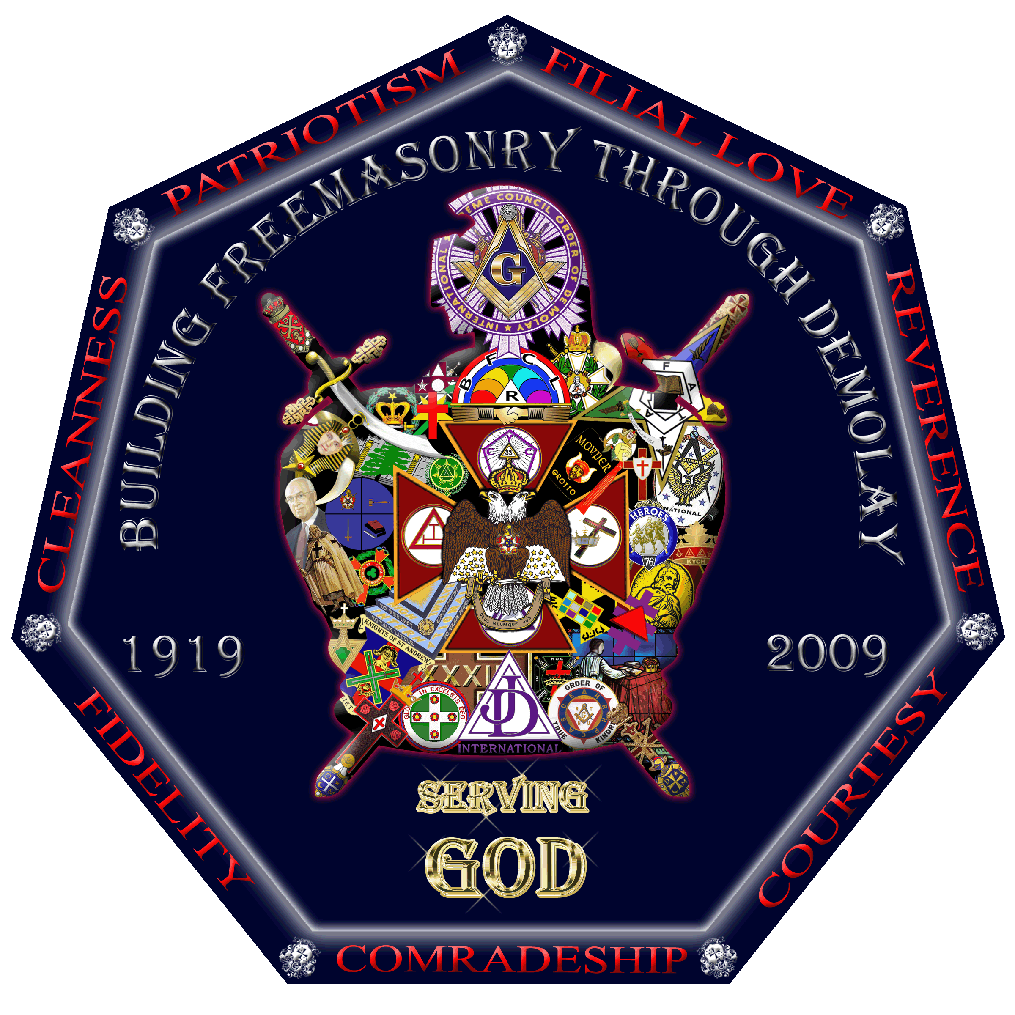

Grand Master’s DeMolay International Leadership Conferences

Grand Master Robert W. Cockerham, along with International Master Councilor Benjamin Turconi and International Congress Secretary Jaymie Jordan cordially and fraternally invite you to attend one or all four of the Leadership Conferences that are being planned.

The dates and locations are as follows:
September 19, 2009…..Kansas City, Missouri
November 21, 2009…..Washington D.C.
January 16, 2010…..Nashville, Tennessee
March 27, 2010…..Reno, Nevada
These dates were announced at Session and some were even made over a year ago.


Each Conference will be unique in its own way and special guests have been invited to participate. These invitations have been extended to some, but when others hear the exciting news about DeMolay they want to be involved as well. These plans are evolving as you read this. If you have a great suggestion, please let us know at jkitsmiller@demolay.org. Who knows, your idea could spark a great deal of enthusiasm and excitement not only in your Chapter or Jurisdiction, but throughout the DeMolay World.

Each Conference will also have its own unique theme as follows:
September…..Membership
November…..Communications
January…..Ritual
March…..Activities

Each conference will officially begin on the Saturday morning and conclude with dinner and something exciting after or during dinner. You should plan on arriving on Friday evening sometime so you do not loose out on any of the fellowship and fun.

You are most likely asking, who should attend?
Executive Officers
Jurisdictional Staff Members
Jurisdictional Officers
Advisors
DeMolays
Dads and Moms
Anyone who has a love for DeMolay and wants to see it grow and prosper.

There will be a registration cost for each individual to attend, and they will vary with the location chosen. Hotel costs will be reasonable and you can room attendees in accordance with our policies.

Plan now to attend! Your help in moving DeMolay forward will be the catalyst to start a new momentum!

Let us all work together to make the World of DeMolay a better place than it already is!

Help us to “Build Freemasonry through DeMolay”

Thank you!

Grand Master’s DeMolay International Leadership Conference
Registration

Location: Washington, D.C.

The Conference will be held at the House of the Temple, Scottish Rite Headquarters of the Southern Jurisdiction of the United States, 1733 16th St., N.W., Washington, D.C. 20009. Dinner and entertainment will be held at the George Washington Masonic Memorial, 101 Callahan Dr., Alexandria, VA 22301. Transportation will be provided for those who will need it.

Names Attending:

___________________________________ ___________________________________

___________________________________ ___________________________________

___________________________________ ___________________________________

___________________________________ ___________________________________

___________________________________ ___________________________________

Chapter: ____________________________________________________________________________

Jurisdiction: _________________________________________________________________________

Registration fee: $55.00 per person (Includes lunch, dinner, fun, fellowship, education, and more)

Attached is my check in the amount of: ______________________

Please charge credit card # _______________________________________________

Expiration Date: ___________________

Mail completed registration form and check to the address below. If you are registering by credit card, you may fax your registration paperwork and credit card information to the fax number below. Registration is due one week (11/13/2009) prior to the conference.

Return form with fees to:
DeMolay International
Service and Leadership Center
Leadership Conference Registration
10200 NW Ambassador Dr.
Kansas City, MO 64153
Phone: 1-800-DeMolay Fax: 816-891-9062

All Hotel Reservations must be made directly with the hotel.

Carlyle Suite Hotel
1731 New Hampshire Ave., N.W.
Washington, D.C. 20009
Telephone: 202-518-5006

Room Rate: $99.00 (plus taxes) single/double occupancy
Room Rate: $109.00 (plus taxes) triple/quad occupancy

